**URGENT REQUEST FORM**

**Purchasing Buyer’s Manual**

1. **Go to** [**http://10.27.1.170:9292/default.aspx**](http://10.27.1.170:9292/default.aspx) **and login your account.**

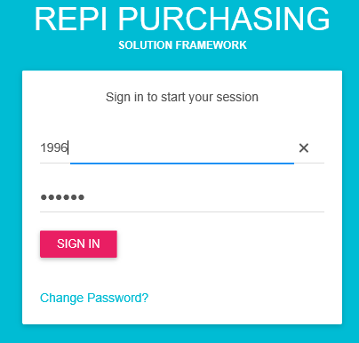

**My Dashboard display you’re “for approvals” based on your user access. You can directly click on the URGENT REQUEST FORM number and it will redirect to the approval form accordingly.**

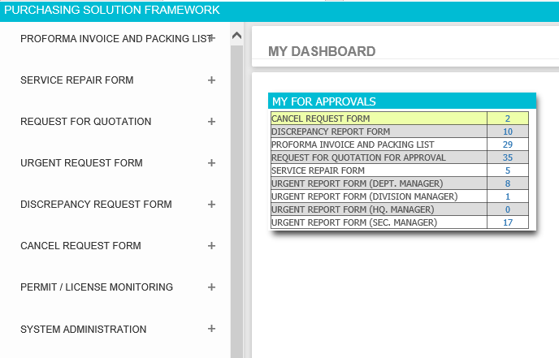

1. **Navigate URGENT REQUEST FORM then click the positive sign (+) button to see all options assigned to your account.**

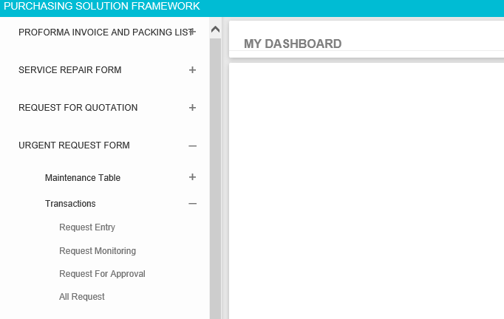

1. **If you want to create new request then go to URGENT REQUEST FORM > Transactions > Request Entry**

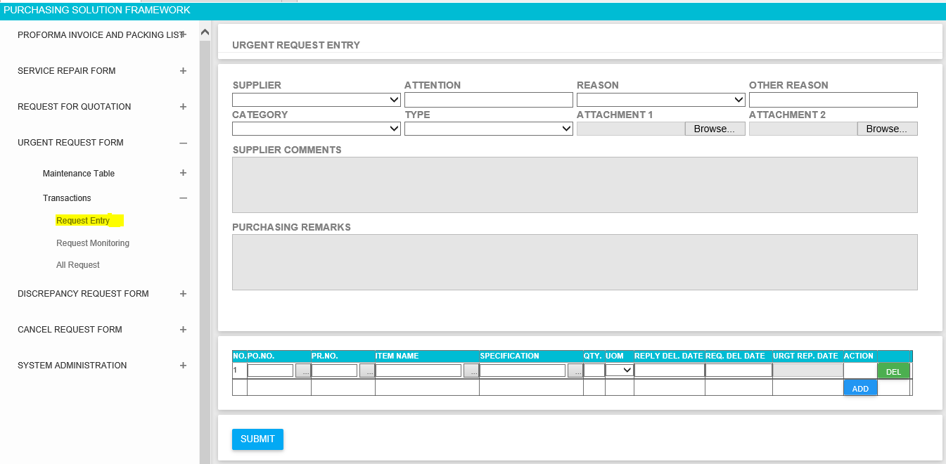

* **3.1 Enter all required field before submitting the request. If you missed to fill up required fields then the system will inform you by marking red colors. See example below;**

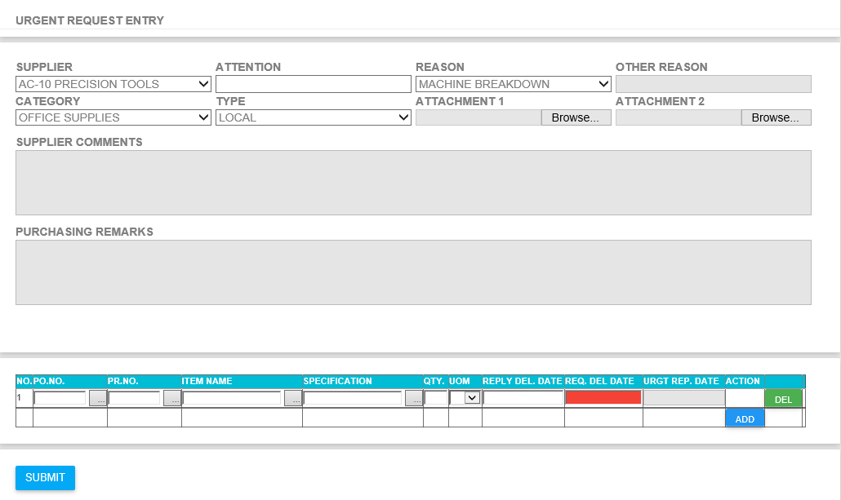

* **3.2 If you have an attachment, please make sure that you finish first all the details before attaching file if there is any. It’s like how you do it in RFQ Module.**

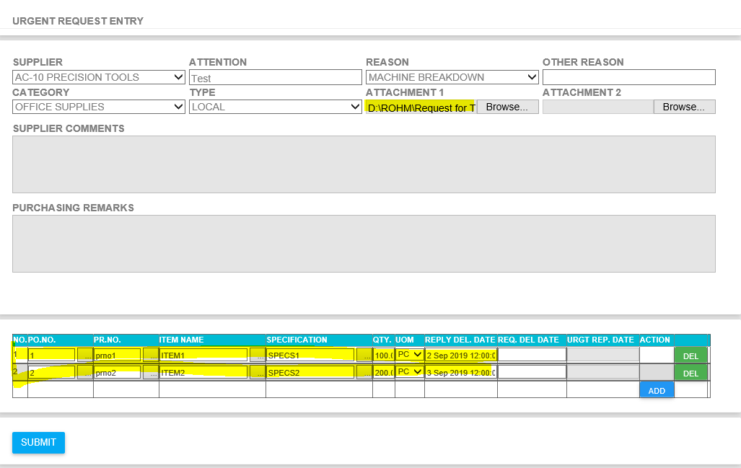

* **3.3 You will be redirected to success page if there is no error after clicking SUBMIT Button**

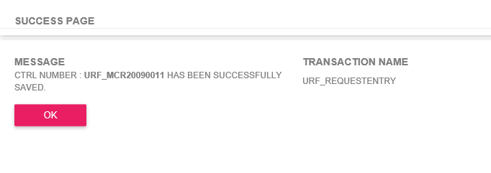

1. **If you want to check or monitor your request the go to URGENT REQUEST FORM > Transactions > Request Monitoring**

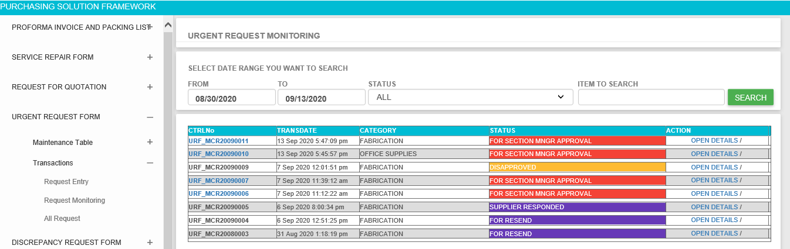

* **4.1 Click OPEN DETAILS if you want to see the request details**

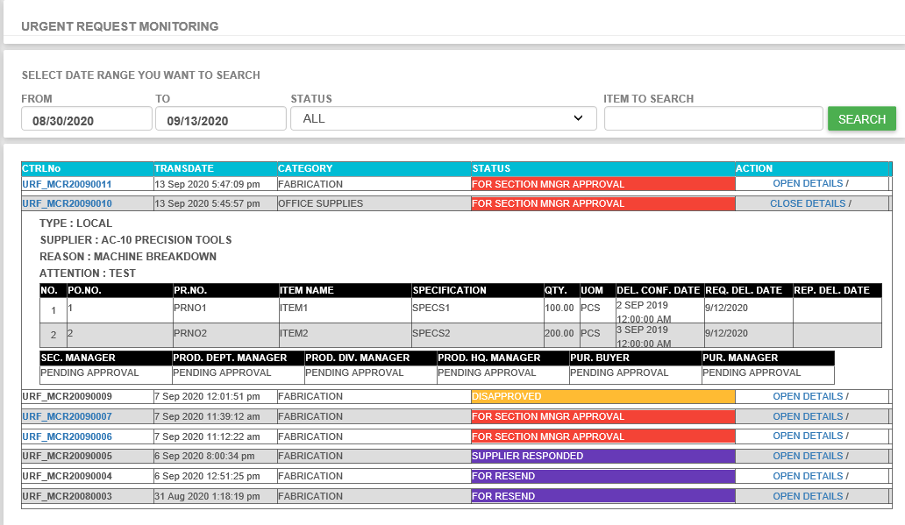

* **4.2 If you missed something on your request then you have chance to update it before your section manager approve the request. Click the URF Number on the left side then you will be redirected to the request entry to update your request.**

1. **If you want see all request the go to URGENT REQUEST FORM > Transactions > All Request. This page is almost the same with the RFQ All Request Form for your reference.**

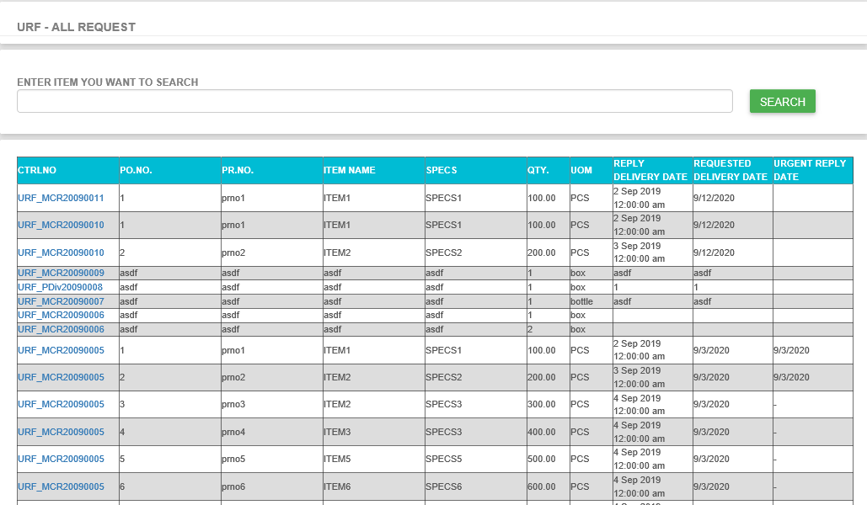

1. **If you want to approved request then go to URGENT REQUEST FORM > Transactions > Request For Approval**

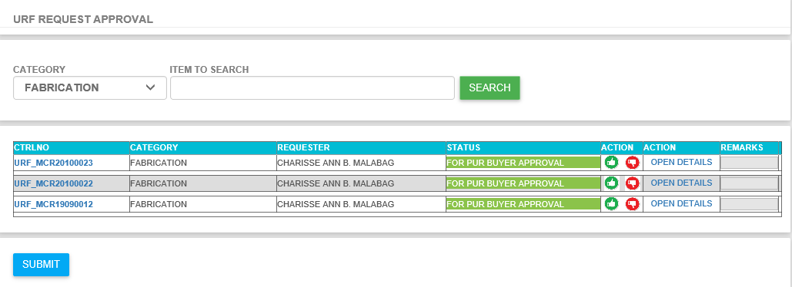

* **6.1 Click OPEN DETAILS if you want to see the request details**

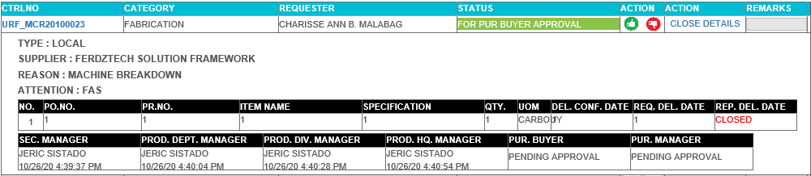

* **6.2 If request is good and ready for approval then click the green thumbs up button in ACTION column then click SUBMIT.**

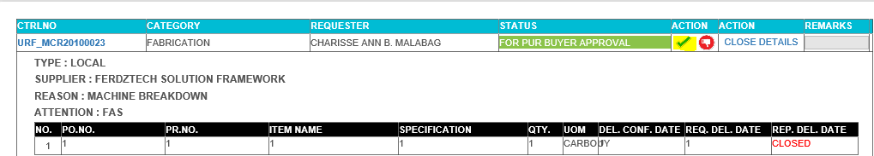

* **6.3 If no error then you will be redirected to successful page.**

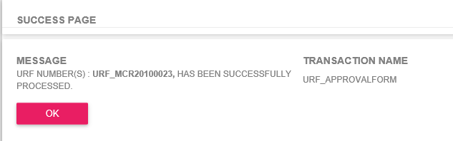

* **6.4 If you want to reject or disapproved request then click the red thumbs down button, add your disapproval remarks then click submit.**

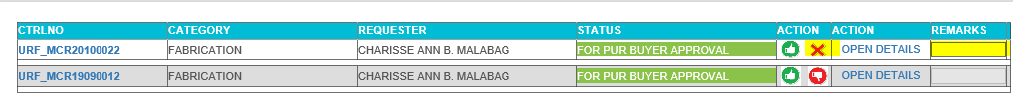

* **6.5 After the buyer approval then the items will move to Purchasing Manager for Approval**

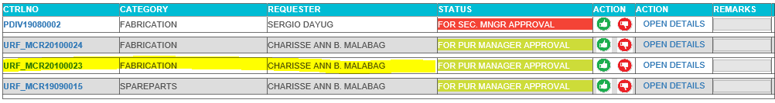

* **6.6 After the Purchasing Manager approved then it will proceed to Receiving Entry “FOR SENDING” by default.**

1. **Receiving Entry**

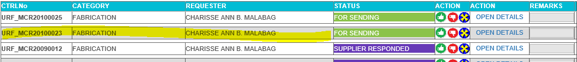

**Same with approval form, you just need to click the green thumb to send to supplier. Once it was submitted the status will change to “FOR RESEND” it means that your item is sent to supplier. You can resend the item by doing the same process. Once the supplier got responded just click the open details to see the responses.**

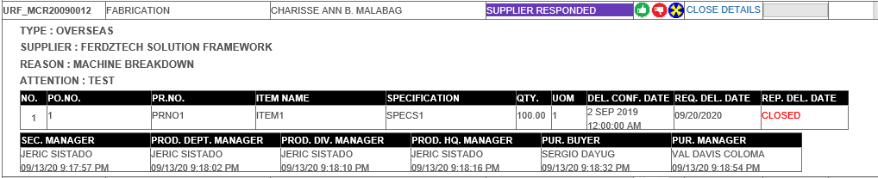

**Once the buyer is satisfied with the response the you can now select the BLUE X BUTTON to close the transaction. This will closed or posted the transaction and will remove in your collections.**